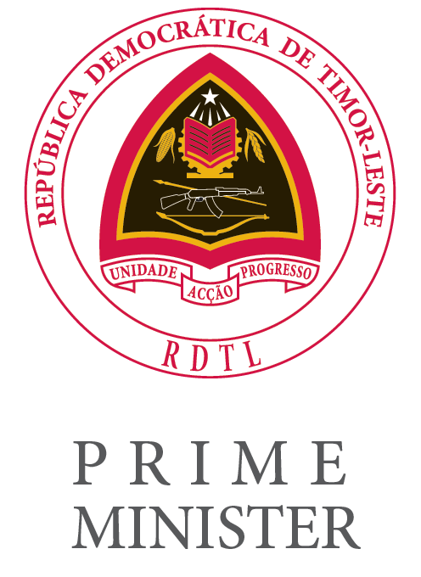

SOLEMN ADDRESS BY
HIS EXCELLENCY THE PRIME MINISTER
KAY RALA XANANA GUSMÃO

ON THE OCCASION OF THE OPENING SESSION OF THE 31st ORDINARY MEETING OF THE COUNCIL OF MINISTERS OF THE CPLP

“THE CONSOLIDATION OF THE DEMOCRATIC RULE OF LAW AND THE CHALLENGES FACING THE CPLP”

Noble Hall of the Ministry of Foreign Affairs and Cooperation, Dili
19 August 2026
Your Excellency, the Executive Secretary of the CPLP,
Your Excellencies, Members of the Governments of the CPLP Member States,
Ambassadors,
Distinguished Guests,
Ladies and Gentlemen,

It is with great joy that the Timorese people welcome to Dili the Members of the Governments of the CPLP Member States for the 31st Ordinary Meeting of the Council of Ministers of the CPLP.

On behalf of the Government of Timor-Leste, I would also like to extend our warmest welcome to you all, and a very special greeting to those visiting our country for the first time.

At this particularly sensitive time for Guinea-Bissau, I wish to begin by reaffirming our profound solidarity with the people of Guinea-Bissau and the firm commitment of Timor-Leste, and of the CPLP as a whole, to supporting efforts towards dialogue, institutional stability and the restoration of the democratic rule of law, so that the country may move forward, with confidence and serenity, on the path towards peace, development and the consolidation of its institutions.

It was precisely to uphold the values of peace, democracy, the rule of law, human rights and sustainable development that the Constitutive Declaration of the Community of Portuguese Language Countries was signed on 17 July 1996, in Lisbon.

As we mark the 30th anniversary of our Community this year, it is important to reaffirm these founding principles and renew our shared commitment to our identity and language, to solidarity, and to cooperation for the development of our peoples.

We should celebrate what unites us and the achievements we have accomplished together. But we must also have the courage to reflect on the weaknesses that remain.

We share what we consider to be the most beautiful language in the world, and through it we have a unique ability to express our feelings and our understanding. Yet words cannot replace action, nor can intentions take the place of concrete achievements.

Three decades after the founding of our Community, I propose that we be bolder and reaffirm, with greater determination, our commitment to go further in achieving the objectives we have set together.
We must find solutions to overcome the challenges facing our countries, acting as the true family we aspire to be.

I am referring not only to the socio-economic disparities within and among our Member States, but also to the journey that still lies ahead towards greater economic and trade integration, more effective use of the financial and human resources available to us, and greater institutional credibility and stability.

Our organisational architecture, based on political consensus, requires us to strengthen dialogue, collaboration and the commitment of all our members in order to ensure the effective and efficient implementation of the decisions taken within our multilateral forum.

To overcome the weaknesses that continue to limit the CPLP's potential, we must equip our institutions with more effective mechanisms for monitoring and evaluating decisions, as well as more consistent funding capable of sustaining strategic projects.

With four years remaining until the deadline established for achieving the United Nations 2030 Agenda for Sustainable Development, I believe that our cooperation must also focus on the most fragile contexts, while increasingly involving civil society, universities and the private sector in the life and projects of the CPLP.

Only in this way can we transform the CPLP into a community of action, built around shared interests and opportunities. A community capable of meeting the legitimate aspirations of our peoples and the historic responsibility we share.

In this way, we could also broaden cooperation among our countries, both in areas where we have already reached consensus—such as mobility—and in those where joint action will make us stronger, including food security, social protection, the fight against climate change, the protection and promotion of the Ocean, resilience to international shocks and instability, and cybersecurity.

Ladies and Gentlemen,

I believe we all welcome the growing interest shown by countries, entities and organisations that have already obtained, or wish to obtain, Associate Observer or Consultative Observer status within our Community. The international recognition of the CPLP is today an undeniable reality and one of which we should be proud.

Timor-Leste's accession to ASEAN in October last year creates a new strategic bridge for the other CPLP countries, not only in terms of trade and investment diversification, but also in terms of the social and human development of our peoples.

It also provides another important platform to promote the humanistic values of tolerance, mutual respect and peace in today's troubled world, marked by uncertainty and conflict.

Extending our experience of solidarity, friendship and dialogue to peoples beyond the CPLP is a real and meaningful contribution to humanity, helping to legitimise the coexistence of different cultures, traditions, knowledge and aspirations.

This may seem like a small gesture towards building peace, but it is a giant one when compared with the intransigence and indifference shown by some of the world's major Western democracies today.

It is also for this reason that I am pleased to learn of the approval of the application of the Asian Portuguese Community Association (APCA) for Consultative Observer status within the CPLP. Bringing the CPLP closer to the centuries-old communities of this region that continue to preserve our shared Portuguese-speaking cultural heritage is an act of diplomacy and reinforces the motto of our 30th anniversary: "Unity in Diversity, a Community for the Peoples".

Your Excellencies
Ladies and Gentlemen,

I do not wish to prolong these opening remarks, as I am aware that the working session that follows has a long and demanding agenda.

Allow me, however, to recall that Timor-Leste assumed the pro tempore Presidency of the CPLP because of the situation that affected Guinea-Bissau last year.

What Timor-Leste has accomplished and continues to undertake during its Presidency, and what remains to be done, would not have been possible without the support of the Executive Secretariat and the commitment and trust of the Member States, for which we are deeply grateful.

The theme we chose for our Presidency, "The Consolidation of the Democratic Rule of Law and the Challenges Facing the CPLP", was intended to encourage the kind of reflection I have proposed today, not only on our organisation and our community of countries, but also on the global context we now face.

The legitimacy of our processes of reconciliation, democratic construction and reconstruction, and the genuine alliance we have been able to forge among our countries despite our differences, have given us valuable experience and knowledge from which to draw lessons when considering other processes and challenges around the world.

We have a collective voice in defence of human dignity, peace, justice, and the preservation of the Ocean and our planet. And we must amplify that voice.

We therefore have a duty to show solidarity with and support peoples who suffer, both within and beyond our Community. What meaning do our principles and values have if we remain indifferent to the suffering of a brotherly people within our Community or within our region of influence?

Allow me to recall another people whose struggle for freedom and human rights is painfully familiar to us.

I am referring to the Sahrawi people, who have waited for so many years to exercise their right to choose their own future. The prolonged impasse, the world's indifference to their suffering, and their legitimate aspirations under the principles of the Charter of the United Nations challenge us to reflect seriously on how we, as a Community, can reach a consensus and make our collective voice heard.

The presence of our brother country, Portugal, on the United Nations Security Council during the 2027–2028 term is a source of pride for us all. And Portugal will not be there solely in its own name. As President António José Seguro has stated, Portugal will carry with it the voice and values of our Community, representing this shared space of countries, principles and responsibilities in the world.

I therefore believe that Portugal's diplomatic priorities for this term are also priorities for our entire Community. I am convinced that all its Member States can and should help realise that noble ideal of Portugal as a “bridge-builder, committed to global dialogue”, giving it concrete expression through our actions.

Your Excellencies
Dear Friends,

A final word to commend the work carried out over the past decade in implementing the CPLP Strategic Vision, which has laid important foundations for our common action.

The work beginning today towards the preparation of the future CPLP Strategic Vision for 2027–2033 will, I am confident, enable us to deepen political and diplomatic coordination and multisectoral cooperation, while also enhancing the Community's international visibility.

I therefore hope that this new cycle ahead will bring greater mobility and closer ties among our citizens; young people fully engaged as a true strategic pillar of our future; and greater economic, social and food security for all those who, in each of our countries, bring the CPLP to life.

None of this, however, will be possible unless we work together to safeguard peace, protect the climate and preserve our planet. Because without peace, there can be no development. Without a stable climate, there can be no sustainable future. And without a healthy planet, there can be no common home for our peoples, nor any legacy that we can leave with dignity to the future generations of our Community.

Long live the CPLP!

Thank you very much.
Kay Rala Xanana Gusmão

